Aerospace Logistics (ASL) Ltd  Unit B2 Foundry Lane  Horsham  West Sussex RH13 5PX | 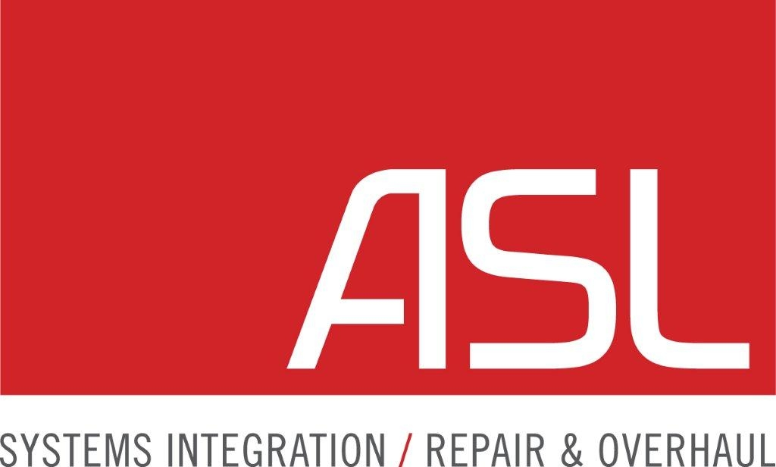
Aerospace Logistics (ASL) Ltd requests your help. Please complete the following Customer Satisfaction Survey based on the project / product / service we recently completed for your organisation. Thank you for your time.

Customer Satisfaction Survey
Customer Name: | Project Name: | Project / Order Number:
[Customer Name] | [Project Name] | [Project Number]
Project Manager/  Lead Contact: | Date:
[Project Manager] | [Date]

Did the project / delivery team / product team deliver the results and quality that were promised?
 | Less than expected |  | As expected |  | More than expected |  | Consistently more

Were key project deadlines met with a “whatever it takes” attitude?
 | Less than expected |  | As expected |  | More than expected |  | Consistently more

Was consistent discipline and direction provided on approach, scope, and schedule?
 | Less than expected |  | As expected |  | More than expected |  | Consistently more

Did the project team / delivery team guide your staff and project results? Were they “team players”?
 | Less than expected |  | As expected |  | More than expected |  | Consistently more

The process was …
 | Less than desirable |  | As expected |  | Better than expected |  | Consistently better

Was there open and timely communication? Did the project team / delivery team act as a team?
 | Less than expected |  | As expected |  | More than expected |  | Consistently more

Were the right personnel consistently assigned throughout the project / process?
 | Less than expected |  | As expected |  | More than expected |  | Consistently more

Was the project team / delivery team creative and flexible in their approach to meeting objectives?
 | Less than expected |  | As expected |  | More than expected |  | Consistently more

Did the project team / delivery team listen, learn, and then execute solutions to overcome challenges?
 | Less than expected |  | As expected |  | More than expected |  | Consistently more

The overall service on this project was …
 | Less than desirable |  | As expected |  | Better than expected |  | Consistently better

Comments / Testimonial:
[Add your comments here.]
Please check this box to grant us permission to use your company logo and testimonial on our website or in our future marketing efforts.
Please check this box if you are willing to act as a reference for our company in the future.
Thank you very much for taking the time to complete this survey. Your feedback is valued and very much appreciated!

For ASL

